Database Backup with ORM stack

Contents

1. Introduction 3
2. Workflow diagram to deploy the stack 3
3. Create stack for Database backup 4
4. Plan the Job 6

Introduction

The Oracle Database Cloud Backup Module for OCI makes it possible to perform backups and restores with Oracle Cloud Infrastructure. Backups are stored in Oracle Cloud Infrastructure Object Storage.Oracle Database Cloud Backup Module for OCI is a system backup to tape (SBT) interface that is integrated with Recovery Manager (RMAN). You can use standard RMAN commands to perform backup, restore, recovery, and maintenance operations.

Workflow diagram to deploy the stack

Below diagram shows how the Terraform Artifact are applied in the OCI. While creating a ORM stack, using terraform deliverables Init, Plan and Apply is the flow to provision the resource in the OCI. We can have the deliverables in any of below.

- GitLab/GitHub Repo
- Bitbucket
- Can be in folder/.zip in the local disk
- Object Storage Bucket
- Can be in compartment
- Oracle provided Template


Create stack for Database backup

Go to OCI Console Developer Services Resource Manager Stacks select the compartment Create Stack

My Configuration Folder Browse Select the “database_backup” folder that contains the terraform Upload

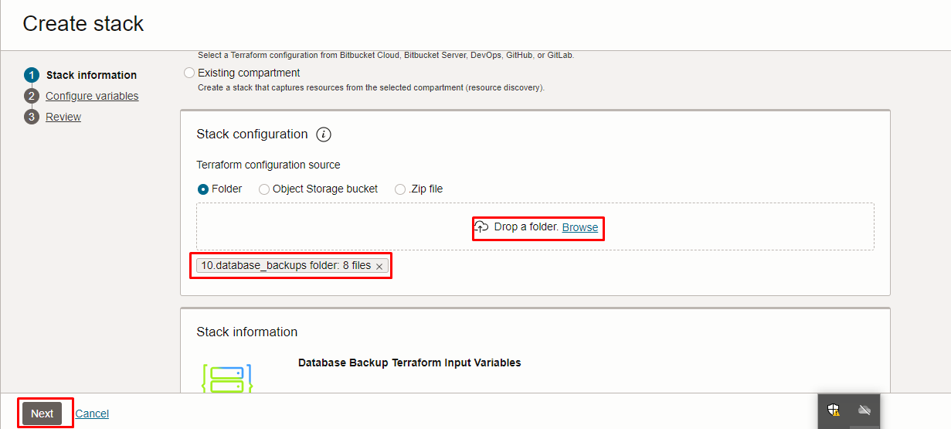

Select the parameters as per the below screen,
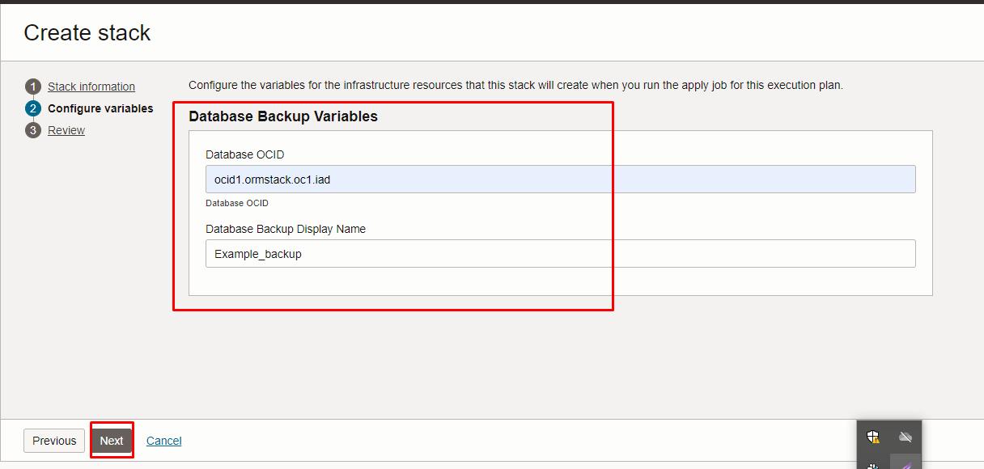

Click “NEXT”
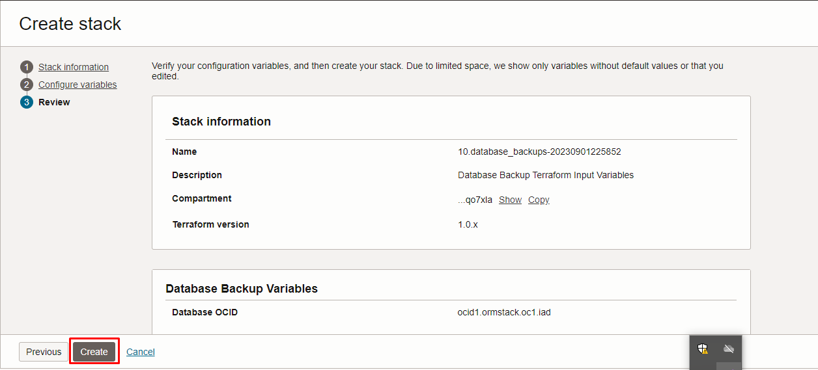
Click “CREATE”

Plan the Job
Click the “Plan”
